**48 Hour Email Banners**

In making 48 hour email banners please follow the guidelines.

1. There are 3 banner sizes

* TV banner size – 16” width X 9” height, 300 res
* 48 hour banner size – 734px width X 285px height, 150 res
* 8.5” width X 11” height, 300 res

1. Elements in the Dolphin Scuba Website that must be in the banner
2. Name of the Product
3. Sale Price - will be provided by Dolphin Agents
4. Regular Price
5. Product Image

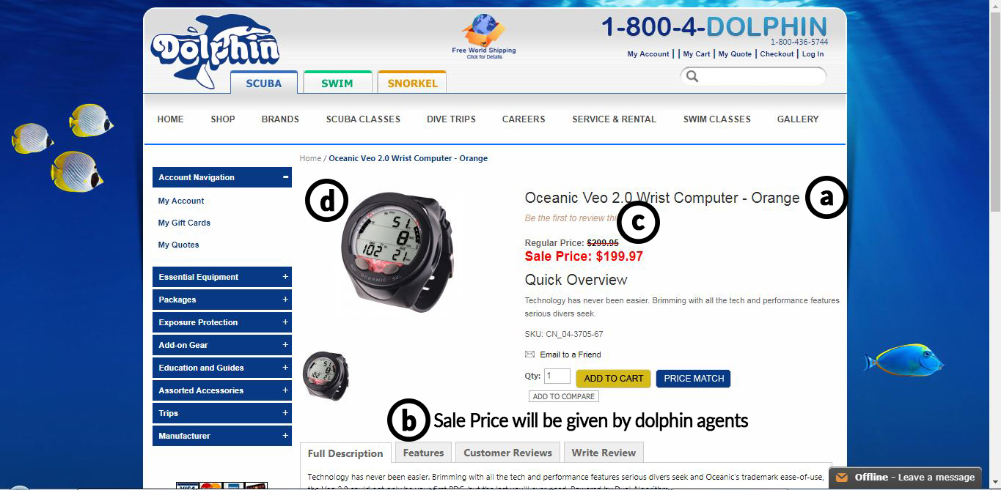

1. Elements that must be in the banner
2. Name of the Product
3. Sale Price
4. Regular Price – the price must have a Strikethrough line
5. Product Image

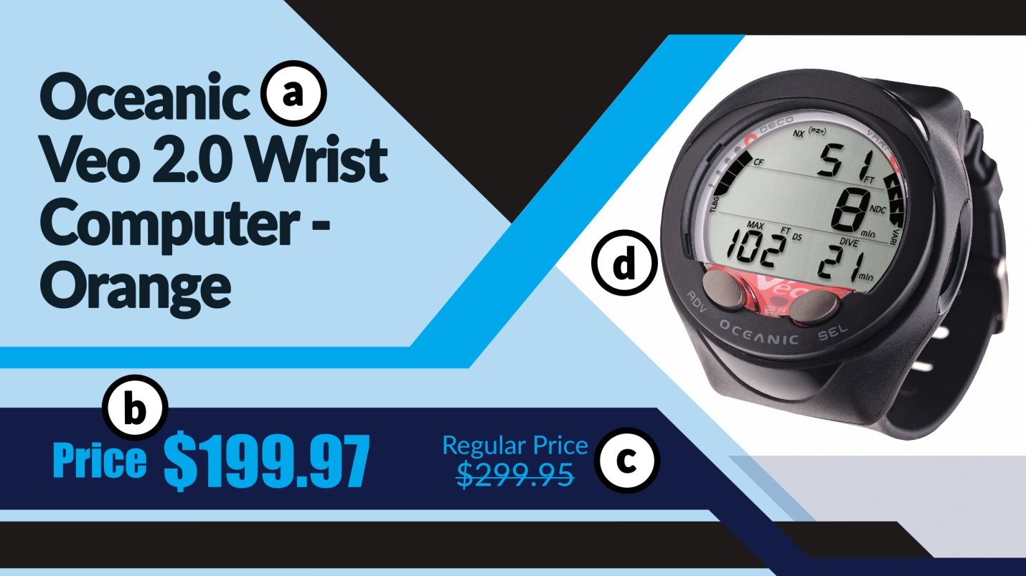

1. The color schemes of Dolphin Scuba are any shades of blue. Avoid using color yellow.
2. Give the images along with PSD files so they can edit the banner in a short notice.
3. Send the output to Dolphin Agents through email so that the image quality will not be compromise.